iBigWorld:
Innovations for Big Data in a Real World
Erasmus+ project 2020-1-PL01-KA203-082197
01.10.2020 – 31.08.2022

Multiplier Event E2
Report
by University of library science and information technologies (ULSIT)

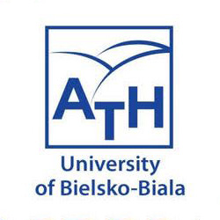

Table of content

Introduction 3
Preparations 3
Event 4
Follow-up 11
Attachments 12
Evaluation survey 12
Presentations of reports 15
Video recordings 15
Participation list 15

Introduction

Multiplier Event E2 has been an integral part of the iBIGworld project’s dissemination and exploitation of results activities.

At 02.06.2022 ULSIT was hosted planed an event E2 as the Transnational Conference “BigData for Digital Innovation in Industry 4.0” , Hotel “Vitosha”, Sofia, Bulgaria.
The event conducted a success. Representatives from small and large business organizations, schools, and universities were invited. Registered were 95 applicants from Bulgaria . On the day of the event, 64 participants from the business community and 18 from UNiBIT managed to participate in the conference.

The conference was honored with the presence of scientists from the Technical University - Sofia, Institute of Metallurgy at BAS, American University In Bulgaria, Center for Competence "QUASAR", as well as experts from IBM Bulgaria, Expert Vision, AtScale Ltd, SSRAM Ltd, Lyon Technologies Ltd., BLUE Strategy Consulting, Cluster Sofia city of knowledge and many others. Special guests of the event were the leading experts who participated in the project - professors from the University of Bielsko-Biala, Poland, who were included in the program via video conference.

For the event we’ve had the following objectives:
• to promote and demonstrate the results of the iBIGworld project
• to raise awareness about the benefits of Big Data technology as innovation domain for business
• to promote Big Data innovation amongst SMEs
• to explain the concepts of Big Data innovation
• to present iBIGworld results: the matrix competencies-topics in the field of Big Data, the eLearning platform for training in Big Data using competence-based approach and use case study, and the Smart BigData Job Hub platform
• to encourage public dialogue around the Big Data concept between business managers and trainers

Preparations

From the beginning of the project, the publication of notices was periodically organized, which served to inform the public about the results of the project.
By publishing announcements and interviews about the achieved results and realized events under the project, we strived to reach our real target groups, namely business companies, teachers and students. We used posts on Facebook, publishing news about the project on the official website of ULSIT, as well as articles in national publications.
The invitation to participate in the event was distributed through several channels:
- Facebook posts;
- - Invitation on the official site of ULSIT - https://www.unibit.bg/news/news-events/big-data-for-digital-innovation
- Invitation on the official site of Faculty of information technologies of ULSIT - https://fin.unibit.bg/novini/297-bigdata-for-digital-innovation-in-industry-4-0-registration-form
- invitation sent by mail to our contacts from our local and regional public bodies and academia representatives

The following figure shows the poster through which we informed the public about the upcoming event.

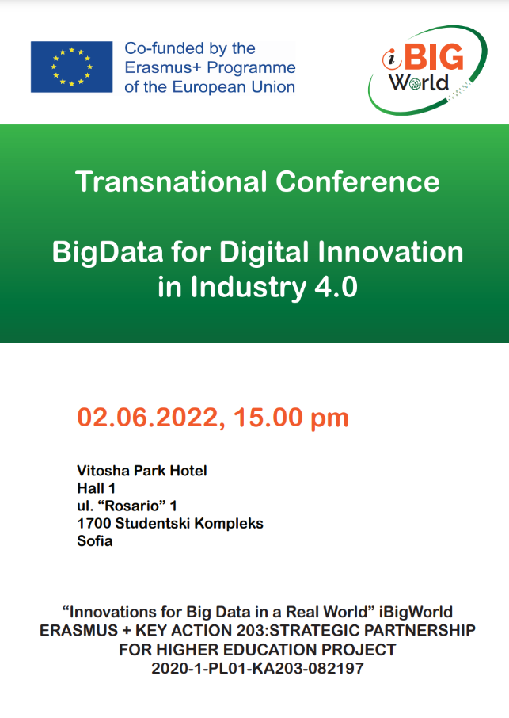

Fig.1. Poster for the event Transnational Conference
“BigData for Digital Innovation in Industry 4.0

A registration form was developed for participation in the event, which was provided to the invited guests (Fig. 2).
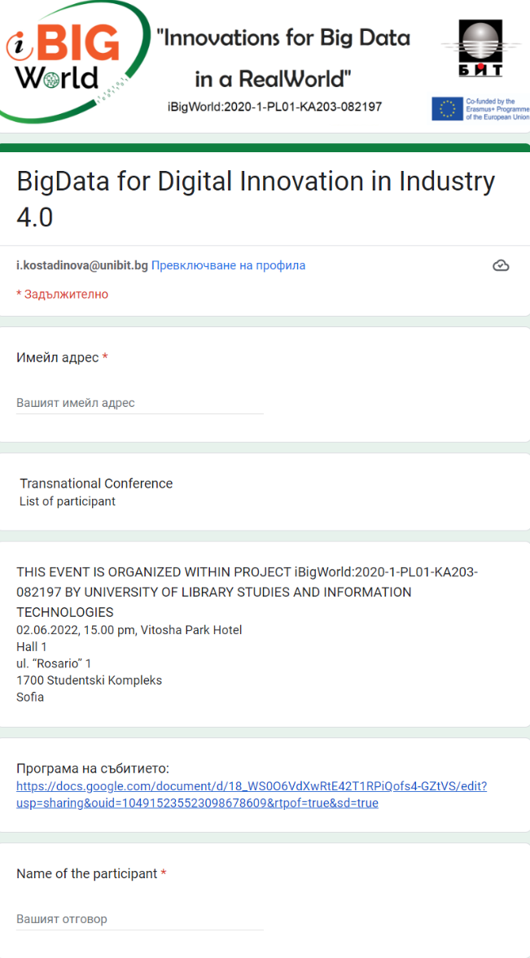
Fig.2. Registration form
“BigData for Digital Innovation in Industry 4.0

Event

For the event, were registered were 95 applicants from Bulgaria. On the day of the event, 64 participants from the business community and 18 from ULSIT joined the conference.

The agenda of the meeting was the following:
Transnational Conference "“BigData for Digital Innovation in Industry 4.0" at 02.06.2022, 15.00 CET (Hotel “Vitosha”)

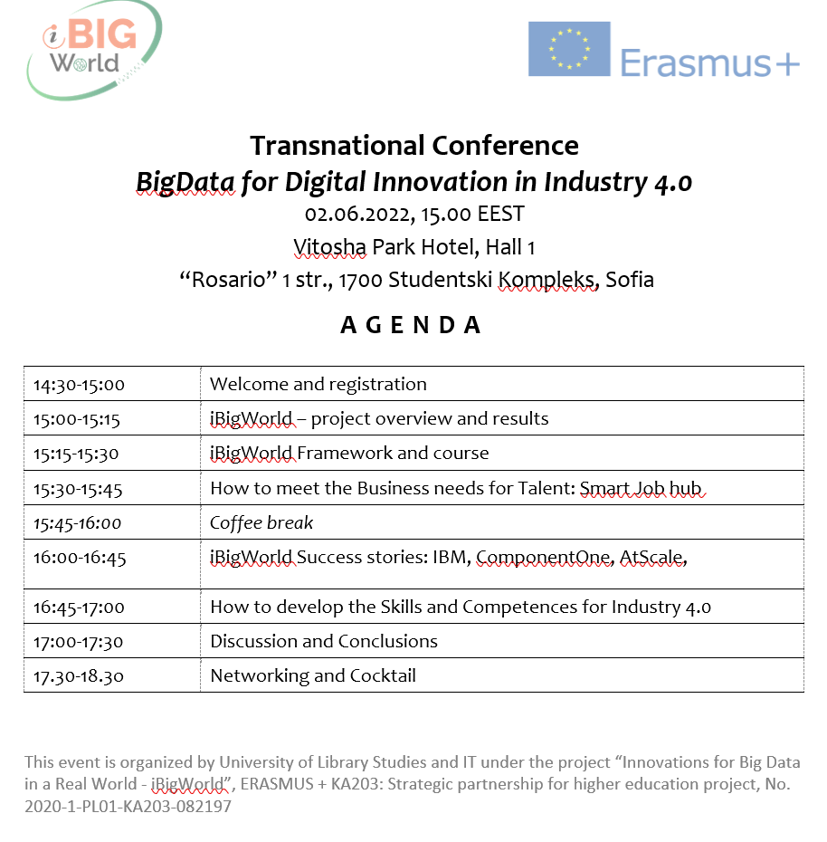

The host andmoderator of the conference was Prof. Georgi P. Dimitrov, who is the leader of the team representing ULSIT in the project. He is also the Deputy Dean for Academic Affairs of FIN at ULSIT.

Guests of the conference were scientists from the Technical University - Sofia, Institute of Metallurgy at BAS, American University In Bulgaria, Center for Competence "QUASAR", as well as experts from IBM Bulgaria, Expert Vision, AtScale Ltd, SSRAM Ltd, Lyon Technologies Ltd. , BLUE Strategy Consulting, Cluster Sofia city of knowledge and many others.
The conference was also attended by the Deputy Dean for Research and International Cooperation of FIN at ULSIT - Assoc. Prof. Dr. Boyan Jekov.
Special guests of the event were the leading experts who participated in the project - professors from the University of Bielsko-Biala, Poland, who were included in the program via video conference.

He also presented the main focus of the conference, namely the presentation of the results of the successful completion of the two phases of the project, whose main task is to overcome the crisis of skills in the field of big data.
Prof. G.Dimitrov presented also the project’s general objectives, target groups, and outcomes of the stage O1 focusing on survey analysis.

Based on these data, 7 surveys were developed, which aimed to collect data from different target groups - survey for students, survey for teachers, for business, for good practices, and IT projects.
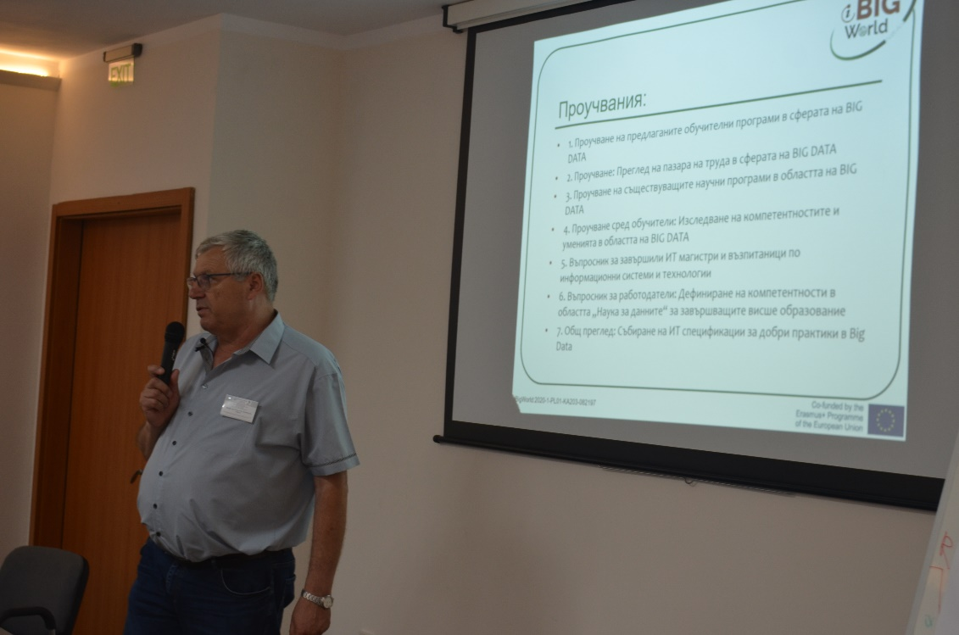

Assoc. Prof. Dr. Evgenia Kovacheva from ULSIT (Bulgaria) joined together with Prof. Georgi Dimitrov and they reported on the experience when developing the Big Data framework implemented as an eLearning platform which includes 12 sequential topics strengthened with various learning activities and use cases from the real world.

One of the leading specialists of AtScale Ltd Todor Grigorov presented his vision of the needs of the business in the field of big data, developing the topic "How to meet the Business needs for Talent".
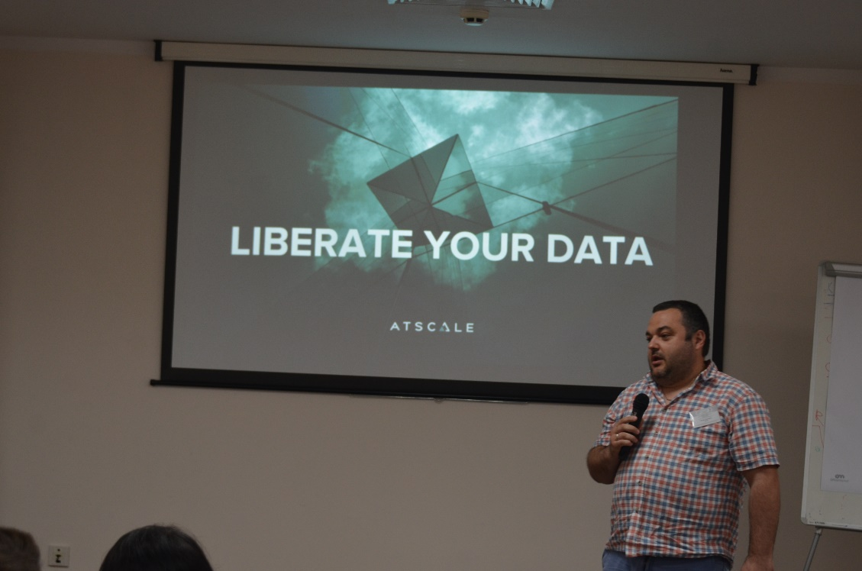

After that, Dr Marcin Bernas (Poland ) has presented report remotely for the developed in connection with the projectSmart Job hub. It will enable the dissemination, mainstreaming, and sustaining of the most relevant results of the project. By delivering, disseminating, and fully operating the Smart BigData Job Hub platform, iBIGworld facilitates access to information that is relevant to Big Data employability opportunities, creates closer links between business and community, eases the transition to the workforce, and contributes to the creation of a sustainable learning community that identifies Big Data cutting-edge industrial needs enabling the reforming of academic curricula.

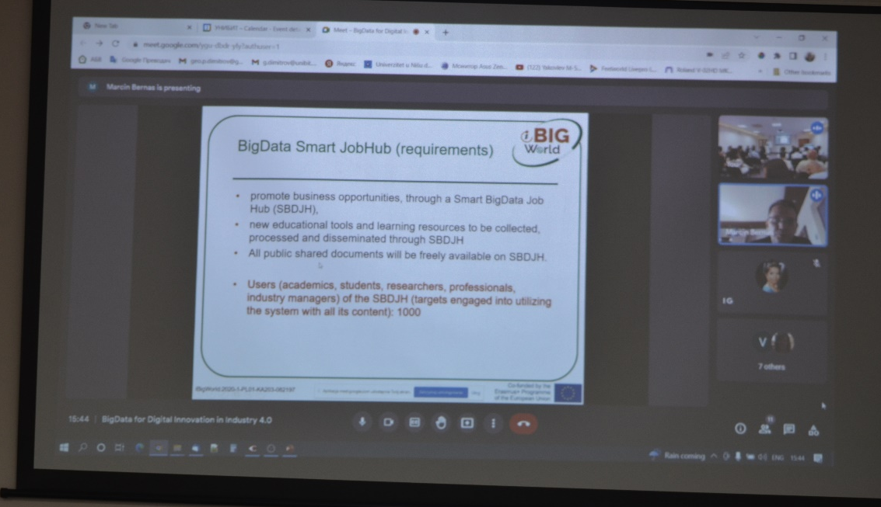

IBM experts Violeta Karanacheva and Rosen Kaplanov, by presenting the topic "iBigWorld Success stories" told how staff can be more successful and develop their careers.
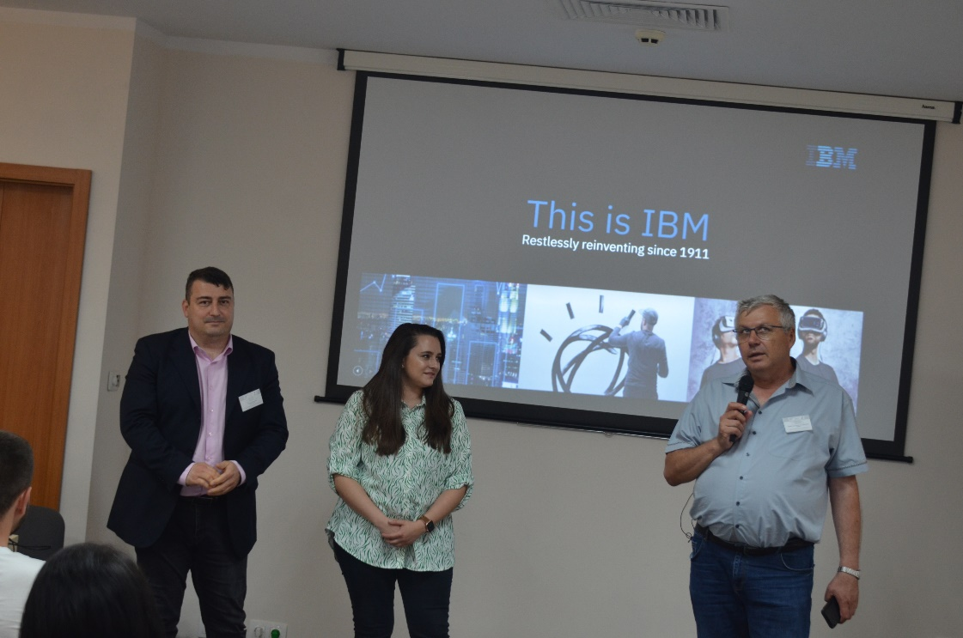

Assoc. Prof. Dr. Evgenia Kovacheva talks about training through building competencies and how to develop the Skills and competencies for Industry 4.0.

Prof. G. Dimitrov gave the floor to one of the lecturers - Assistant Professor Lubomir Gotsev, who participated in the training of students, held in the city of Nis, Serbia, earlier that month.

Lyubomir Gotsev told how the students' training went. How he decided to form international teams by bringing together a student from each of the countries participating in the training.

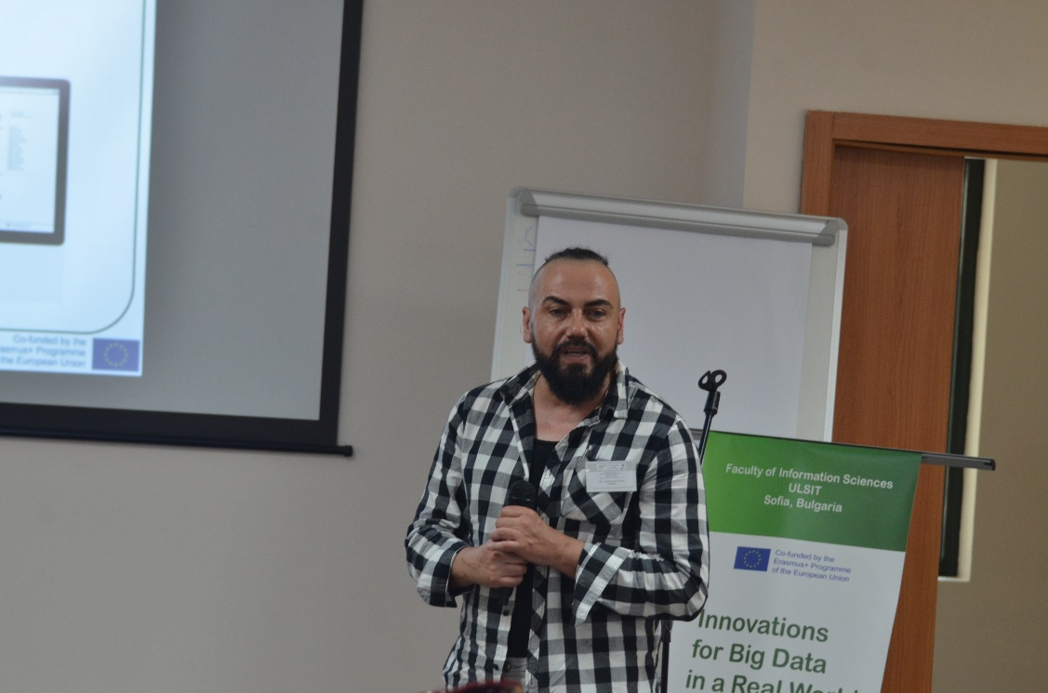

After him, the floor was given to the participants in the training on "Big Data" - students Gabriela Naidenova and Gennady Gospodinov. They told what they had learned and what tools they had used at the training in Nis. They also talked about the international teams to which they were assigned and the final projects they presented at the end of this training - the projects, developed by Orange and Tableau platform with Big Data in a real case.

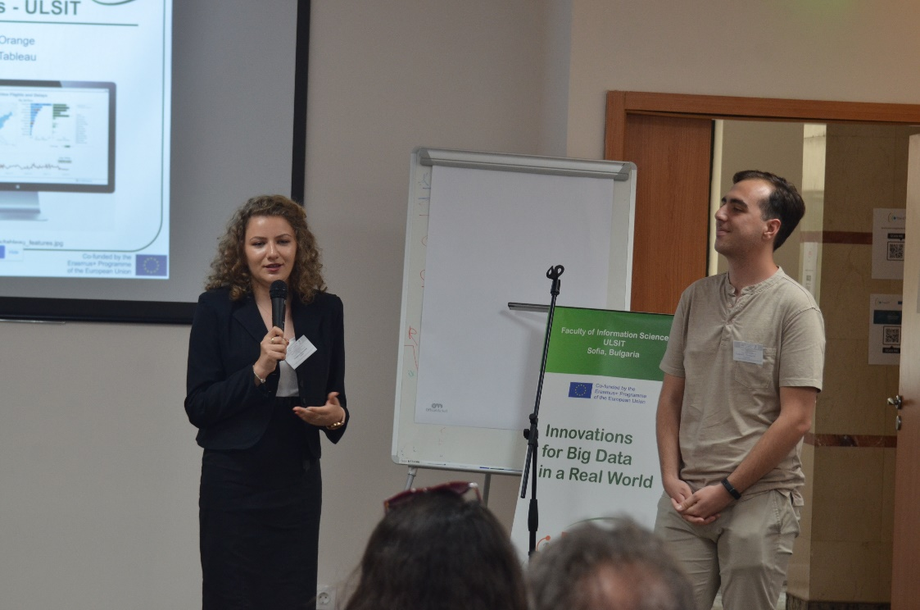

Finally, the event was completed by fruitful discussions and networking.

Follow-up

In order to get feedback from our audience for the conference we organized, we prepared an anonymous survey. Her goal was to understand the opinion of our guests about the project and the topics presented at the conference.
We’ve decided to use an online survey, that participants can access with google form. The evaluation survey had a total of 9 questions. In the attachment has a copy of this online survey in the attachments section.

1. How did you learn about the event?

- Facebook
- LinkedIn
- Email
- The website of the organizers
- From a friend / colleague
- Personal invitation
- Something else:_______

2. In general, how would you rate the event?

- Excellent
- Very good
- Okay
- Average
- Weak

3. How useful was the content of your event?

- Extremely useful
- Very useful
- Somewhat useful
- Not so useful
- It was not useful to me

4. How interesting were the presented topics?

- Very interesting
- Somewhat interesting
- Not so interesting
- They are not interesting to me

5. Which session (s) did you like the most? Why?
Open question

6. Which session (s) did you like the least? Why?
Open question

7. Do you think that the presented results, materials and information will be useful to you?

- Yes
- No
- I can not decide

8. Do you have comments, questions or recommendations about the presented tools for start-ups and small companies and for medium and large companies?
Open question

9. In the future, we should increase the time for:

- Presentations
- Interactive sessions
- Contacts / Networking
- Discussions
- Something else:

Attachments

Evaluation survey
https://docs.google.com/forms/d/e/1FAIpQLSfiHySK4vgzOYhvzb-ZRL-bD3ldOmlVxPhu67TyWck3LR7PUg/viewform
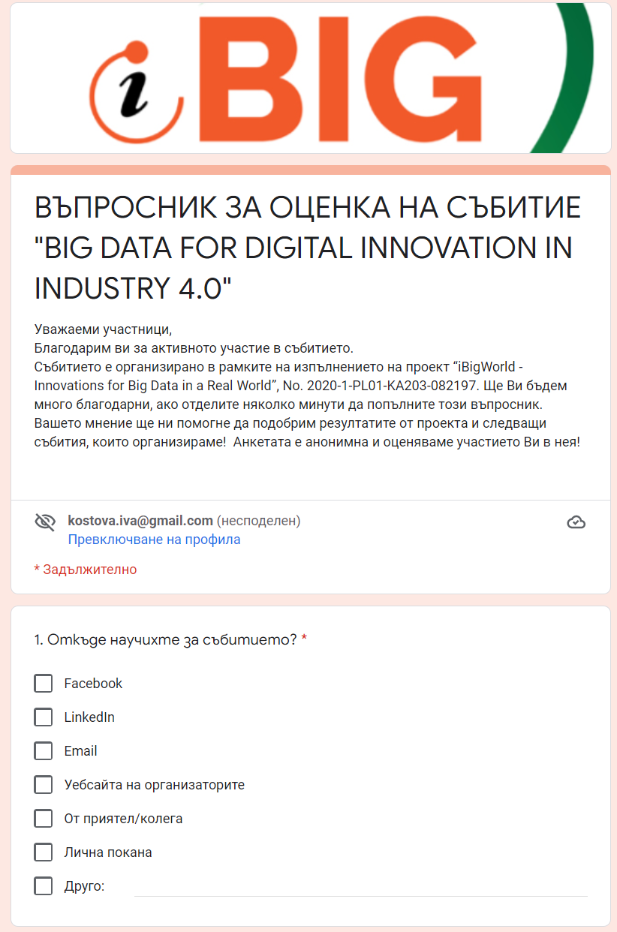

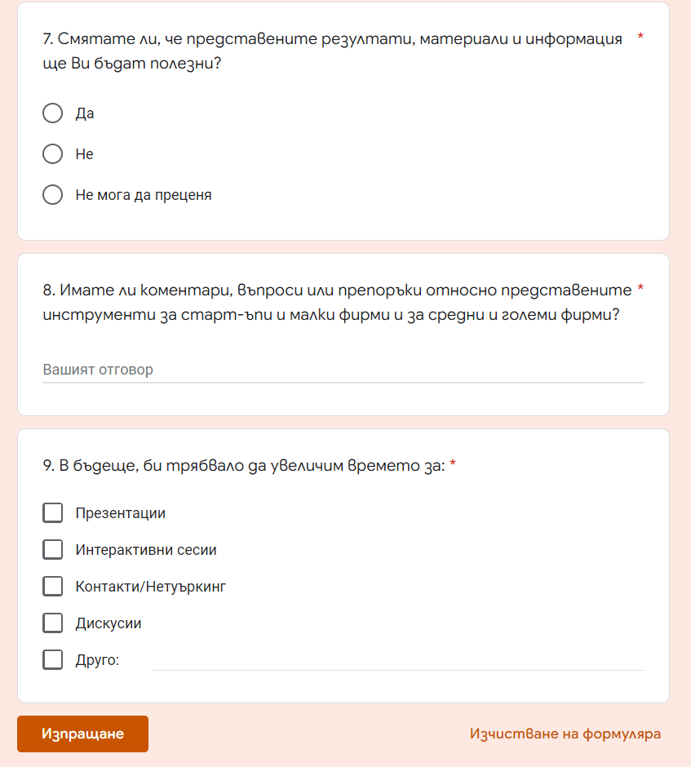

Presentations of reports

Link to the presentations
https://drive.google.com/drive/u/1/folders/1gVrzhWRNBquHyEHHO2oog_bQvO57lIBE

Video recordings

Link to photos
https://drive.google.com/drive/folders/1ojiyV8ncHOR2yaF_FeJ_8pGS_RDST-Yr?usp=sharing

Participation list

Certificate example

