iBigWorld:
Innovations for Big Data in a Real World
Erasmus+ project 2020-1-PL01-KA203-082197
01.10.2020 – 31.08.2022

Multiplier Event E4
Report
by Taras Shevchenko National University of Kyiv

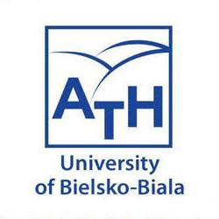

Table of content

Introduction 3
Preparations 3
Event 5
Follow-up 12
Attachments 15
A. Evaluation survey 15
B. Presentations of reports 16
C. Photo materials 16
D. Participation list 17

Introduction

Multiplier Event E4 has been an integral part of the iBIGworld project’s dissemination and exploitation of results activities.

Planned event E4 as the Transnational Conference “iBIGWorld Project Successes and Achievements” was successfully hosted at 14 September 2022 by Taras Shevchenko National University of Kyiv at the Assembly Hall of the Faculty of Information Technologies, Bohdana Havrylyshyna 24, Kyiv, Ukraine.

Representatives from universities and business organizations were invited to take part at the conference. Due to the martial law in Ukraine for those who could not join the conference in person, the distance session of the conference was organized. Therefore, the event was attended by 50 participants in person and 125 participants in distance through the Zoom-meeting. Among all the participants there were 167 local representatives and 8 international representatives. International contingent consisted of 4 representatives from Azerbaijan, 3 – from Germany, 1 – from Turkey.

The aim of the event was to communicate the activities and results of the project within a wider audience consisting of stakeholders and members of target groups. As BigData is cutting edge technology issues that affect everyone, the event also aimed to elaborate on all new perspectives and challenges in the sector that are identified by the European, academic, vocational and expert communities. The speakers were carefully selected in order to encompass an integrated view of all sectors, showing evidence of the interaction between them.

For the event we’ve had the following objectives:
• to promote and demonstrate the results of the iBIGworld project;
• to raise awareness about the benefits of Big Data technology as innovation domain for business;
• to promote Big Data innovation amongst SMEs;
• to explain the concepts of Big Data innovation;
• to present iBIGworld results: the matrix competencies-topics in the field of Big Data, the eLearning platform for training in Big Data using competence-based approach and use case study, and the Smart BigData Job Hub platform;
• to encourage public dialogue around the Big Data concept between business managers and trainers.

The targeted public was made up of the following categories:
• SMEs representatives (staff and management), especially members of the Transilvania IT cluster, managed by ARIES Transilvania;
• Big Data experts, consultants, project managers;
• VET training centers interested to promote the training in Big Data;
• Academics from Management, Technology, and Social sciences;
• Other stakeholders such as clusters and associations.

Preparations

We periodically informed the public about the ongoing results of the project and the events hosted inside of it through the official resources of the Department of Software Systems and Technologies and Taras Shevchenko National University of Kyiv. The purpose of made publications was to reach our target groups, such as students, teachers and business representatives.

The invitation on participation in the Multiplier event E4 was distributed through:
- the official site of the Department of Software Systems and Technologies both in English and Ukrainian - https://pst.knu.ua/news

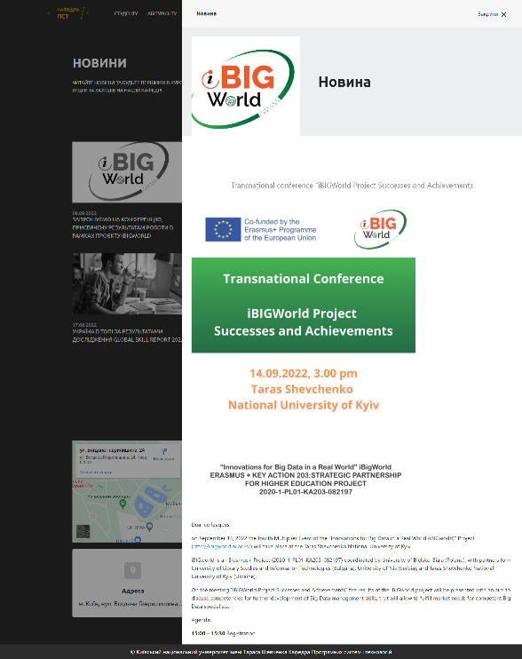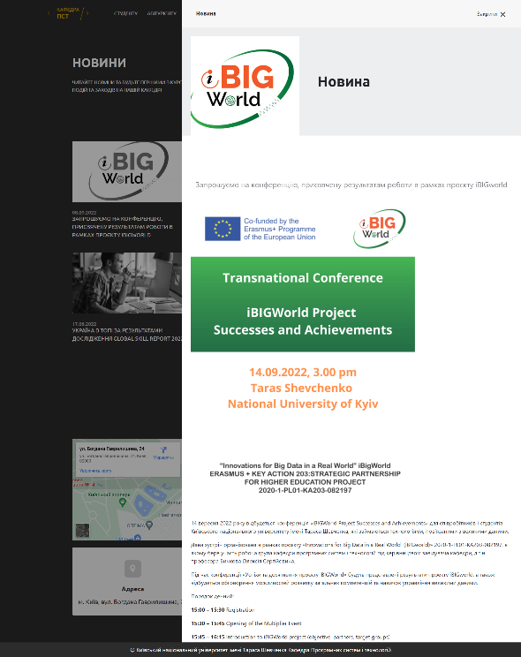

- the official Facebook page of the Department of Software Systems and Technologies both in English and Ukrainian
  - https://www.facebook.com/permalink.php?story_fbid=pfbid02eaGJX9xsu382Ymtfm4FbKY3qMWUEezUe9Wv3DeKwkA94NDCSsC1qk6WMsmgy2ojl&id=100057264287404
  - https://www.facebook.com/permalink.php?story_fbid=pfbid0tc2ZVW2bT4MgccLV1Hmakqtw5pxhbRwthok1vjAeVHsTRycb7RxBzb8Tnus2mS5ol&id=100057264287404

- E-mails sent to our contacts from local and international business organizations and academic areas.

Event

The event was attended by a total number of 175 participants, among them 50 participated in the offline part and 125 joined the distance session of the conference through the Zoom-meeting because of inability to be present in Kyiv due to the diffuculty associated with martial law in Ukraine. Among all of the participants there were experts of small and medium-sized enterprises related to Big Data from Incore Development, Avalex Technology, Variteks Group, Global Media Technology and representatives of higher education institutions from National Technical University of Ukraine “Igor Sikorsky Kyiv Polytechnic Institute”, National University of Water and Environmental Engineering of Rivne, State University of Telecommunications, National University of Water and Environmental Engineering, “KROK” University of Economics and Law.

The agenda of the meeting was the following:
Transnational Conference "iBIGWorld Project Successes and Achievements"
14.09.2022, 15.00 EEST (Assembly Hall of Faculty of Information Technlogies)

Time | Activity
15:00 – 15:30 | Registration
15:30 – 15:45 | Opening of the Multiplier Event
15:45 – 16:15 | Introduction to iBIGWorld project (objective, partners, target groups)
16:15 – 17:00 | Presentation of iBIGWorld project (Intellectual Output #1, Intellectual Output #2, Intellectual Output #3, Intellectual Output #4 and others)
17:00 – 17:15 | Coffee break
17:15 – 18:00 | Expert Panel / How to develop the Skills and Competences / Oleksii Kokhanovskyi (Avalex Technology), Oleksandr Hetman (Incore), Valerii Yakubovskyi (Variteks Group)
18:00 – 18:30 | Discussion and Conclusions
18:30 – 19:00 | Networking

The event was hosted and moderated by Sc.D., Prof. Oleksii Bychkov, who is the Head of the Department of Software Systems and Technologies and the leader of the team representing Taras Shevchenko National University of Kyiv in the project.

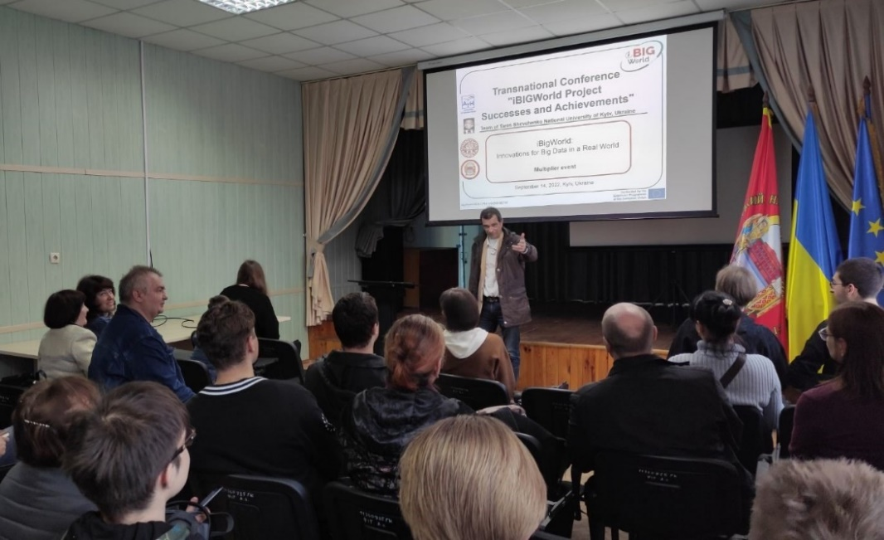

Sc.D., Prof. Oleksii Bychkov has opened the event and welcomed all the participants that that have joined the conference in person and through the online meeting.

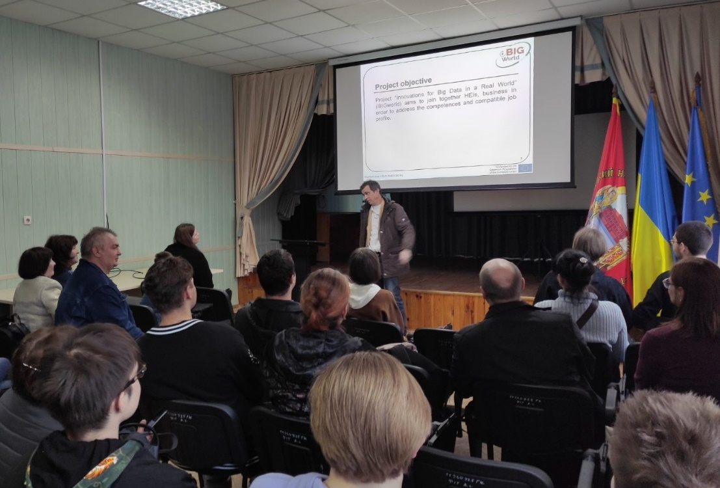

Ph. D., Assoc. Prof. Tetiana Kovaliuk has intoduced the audience to the challenges and issues of the modern Big Data field, then presented the main goals and objectives of the iBIGWorld project and the problems it ovecomes.

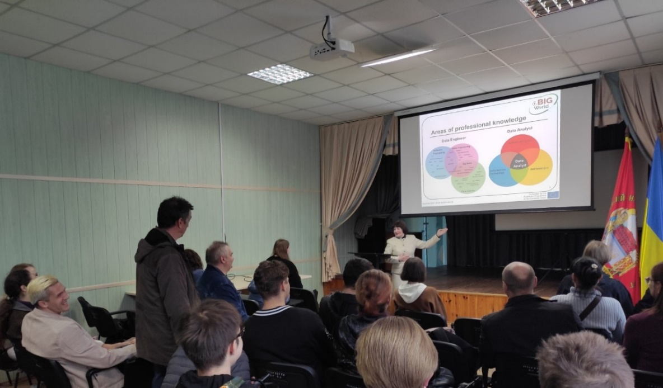

Local manager of the project, Ph. D., Assoc. Prof. Kateryna Merkulova has presented the outcomes of the stage O1 of the project that was devoted to the survey of Big Data stakeholders and analysis of the survey’s results to identify the gaps in current specialists training.

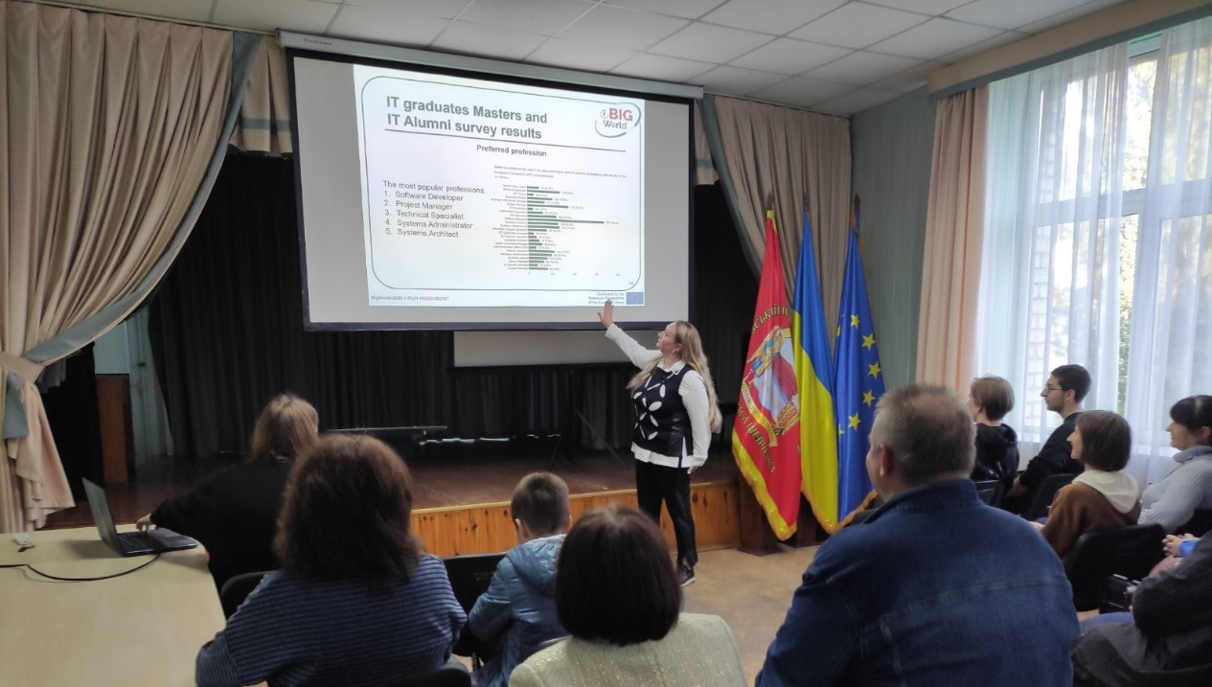

Ph. D., Assoc. Prof. Sergii Dotsenko has presented the outputs of the stage O2 of the project. She have emphasized that on that basis of the stakeholer’s survey partners of the project were able to identify the competences and related to them soft and professional skills that cover the Big Data field as comprehensively as possible to train a competitive Big Data experts.

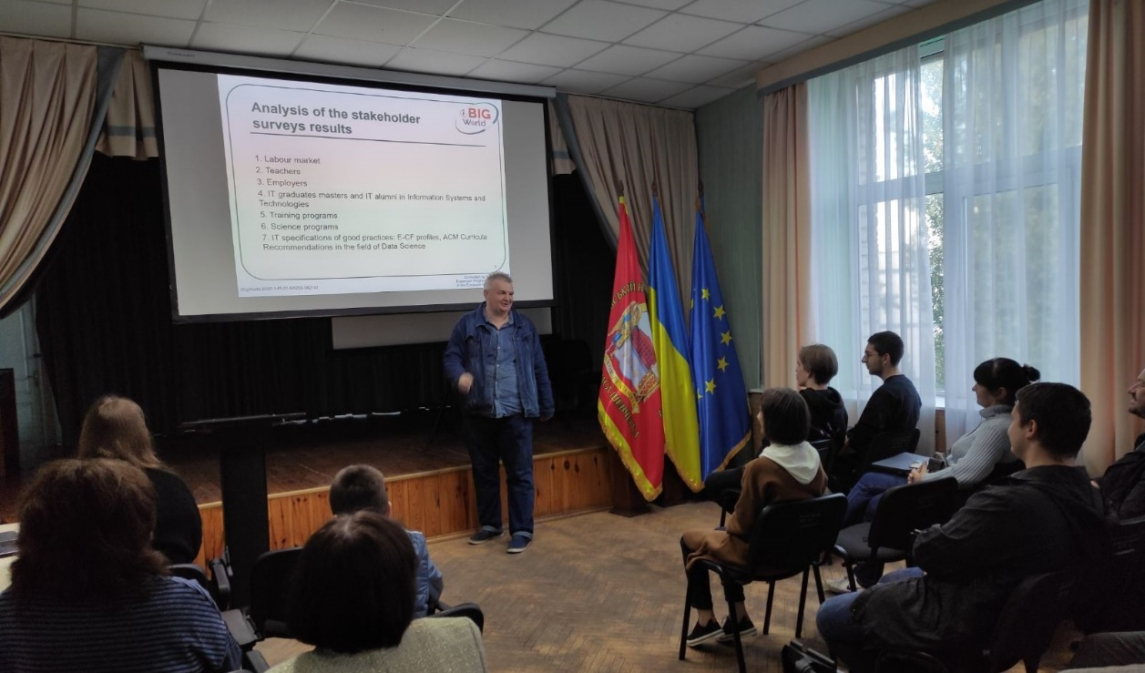

Ph. D., Assoc. Prof. Iryna Yurchuk has reported on the results of stage O3 of the project that was dedicated to the development and implementation of Big Data framework that includes 12 sequatial topics covering the Big Data field with various learing activities and real world use cases. She have presented to the conference participants an eLearning platform that contain materials on Big Data framework and briefly introduced its content.

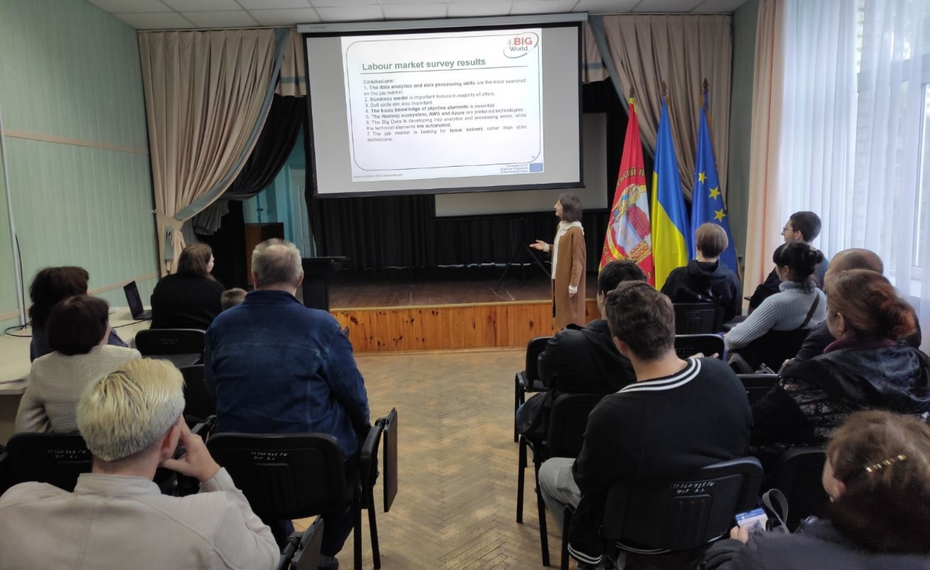

Unfortunately, during the reports an air raid alert was announced all over the Ukraine due to missile hazard. Therefore, the conference organizers and participant were forced to move in the basement shelter of Faculty of Information Technologies. But it did not affect the conference agenda and we continued as soon as every participant was in the shelter.

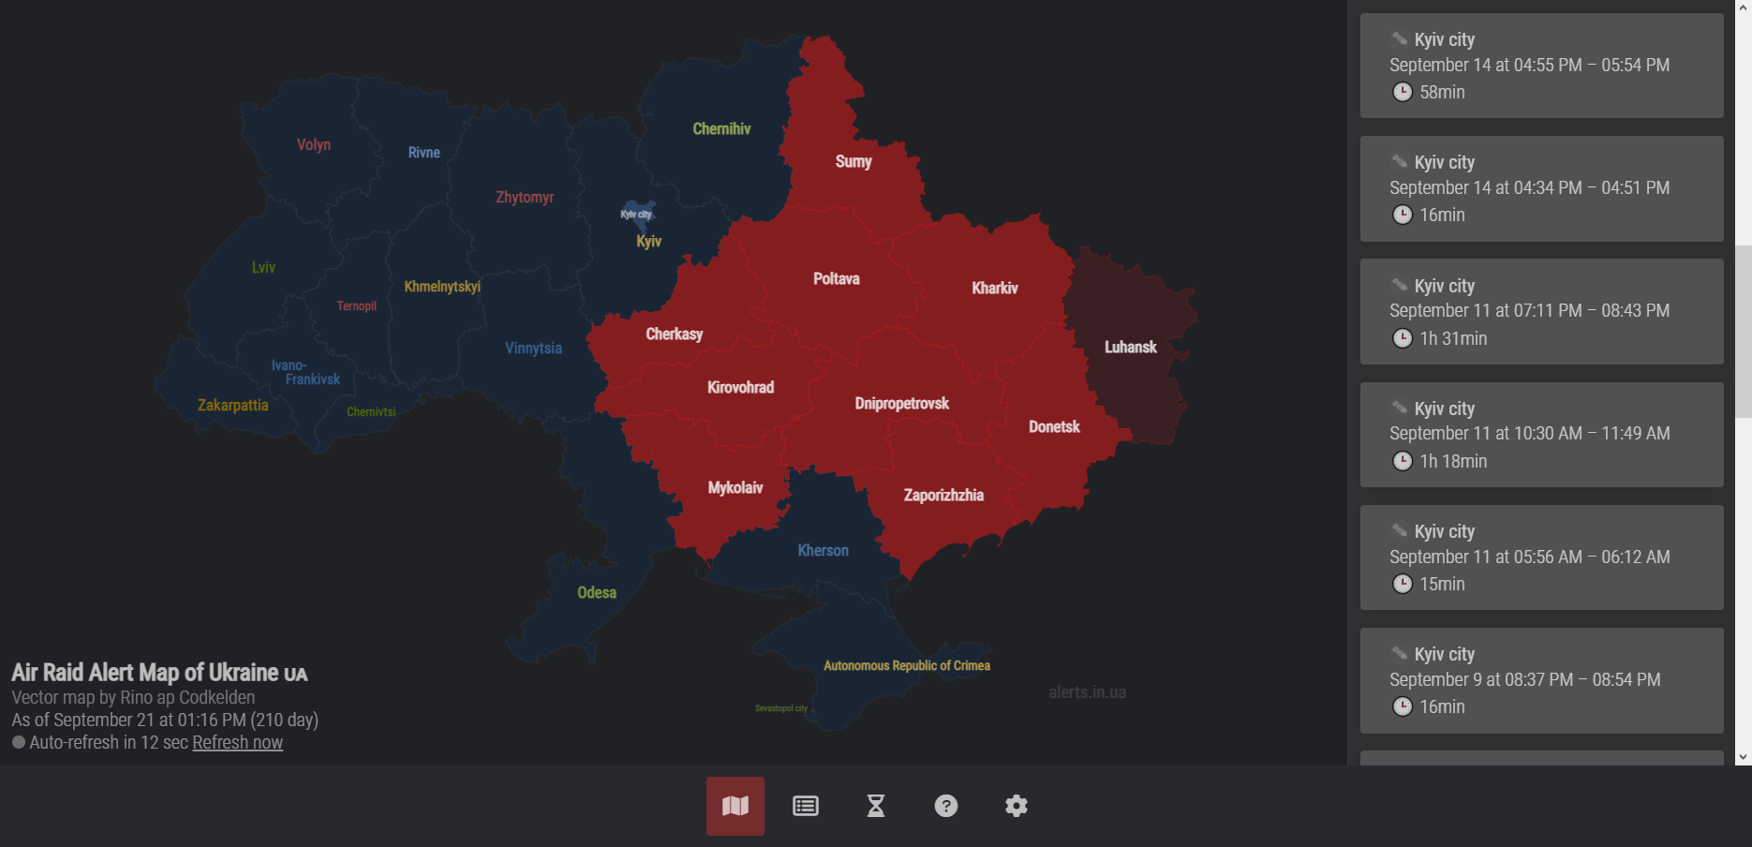

Assistant Yelyzaveta Zhabska has presented the topics of the framework more detailed. After that she introduced the main outcomes of stage O4 of the project, reporting about the approach when developing the teacher and business guidelines, and also Smart BigData Job Hub platform that facilitates the communication between business and Big Data community.

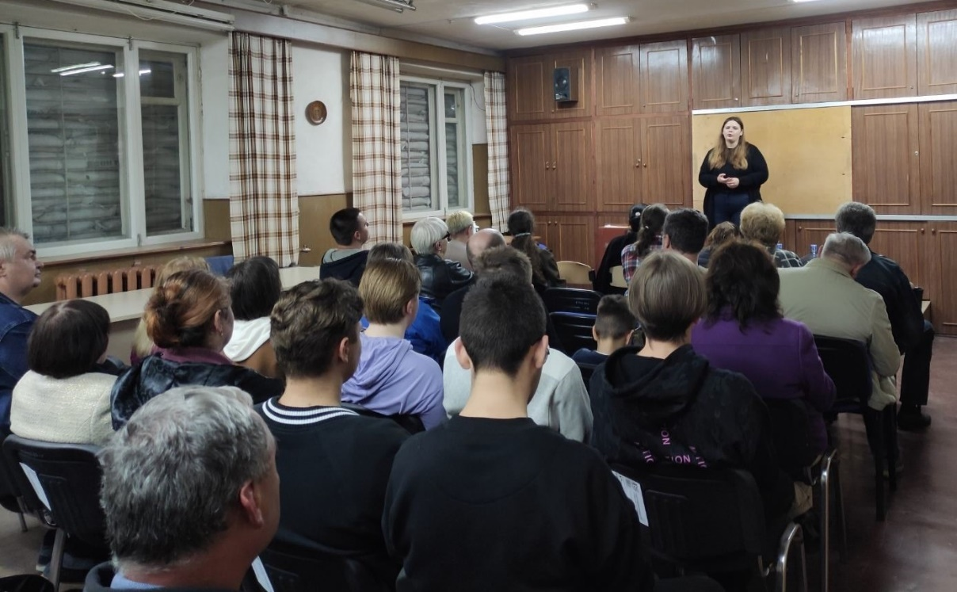

After the presentation of the intellectual outputs of the project the representatives of the business have presented their visions on how to develop the skills and competences in the field of Big Data and how the project outcome correlate to the needs and anticipations of their companies. The speakers for that part of the conference: the Director of Avalex Technology Oleksii Kokhanovskyi, the Director of Incore Oleksandr Hetman, the CEO of Variteks Group Valerii Yakubovskyi.

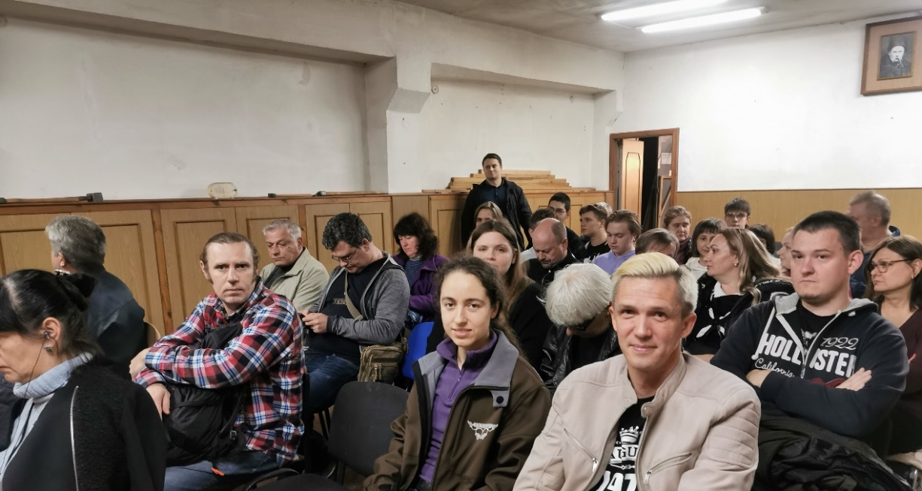

The online session of the conference was held in parallel with its offline part in the Assembly Hall in order to allow to paricipate for everyone who wished, but could not join the conference in person due to the martial law in Ukraine, as well as associated difficulty and hazard of moving.

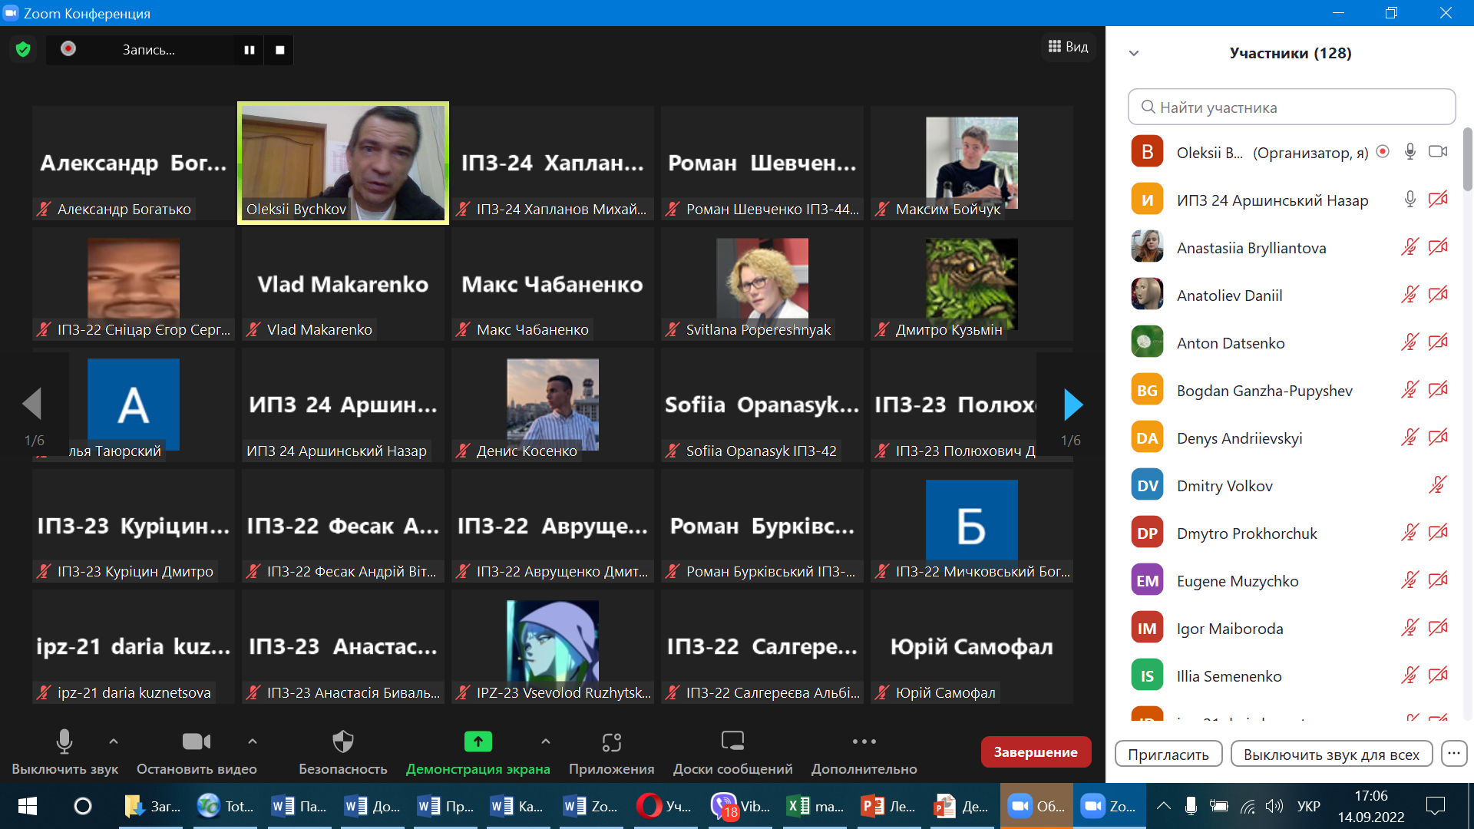

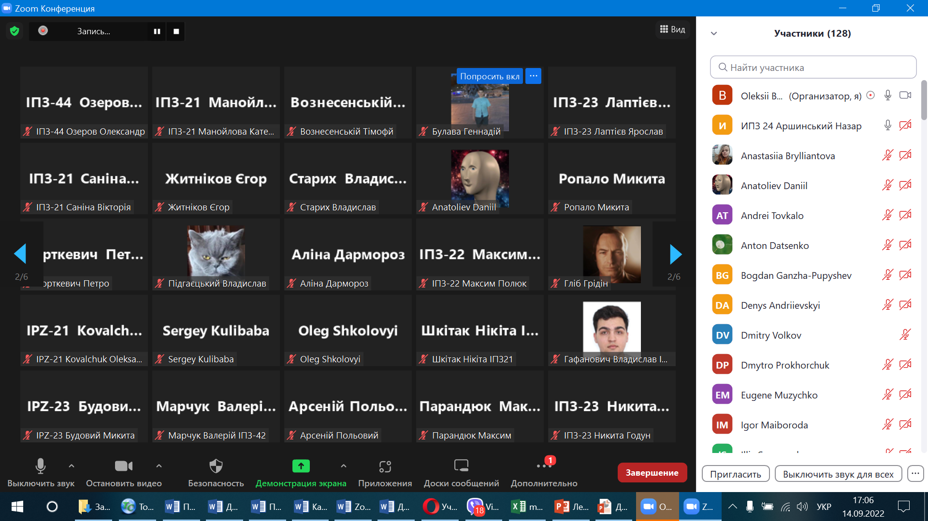

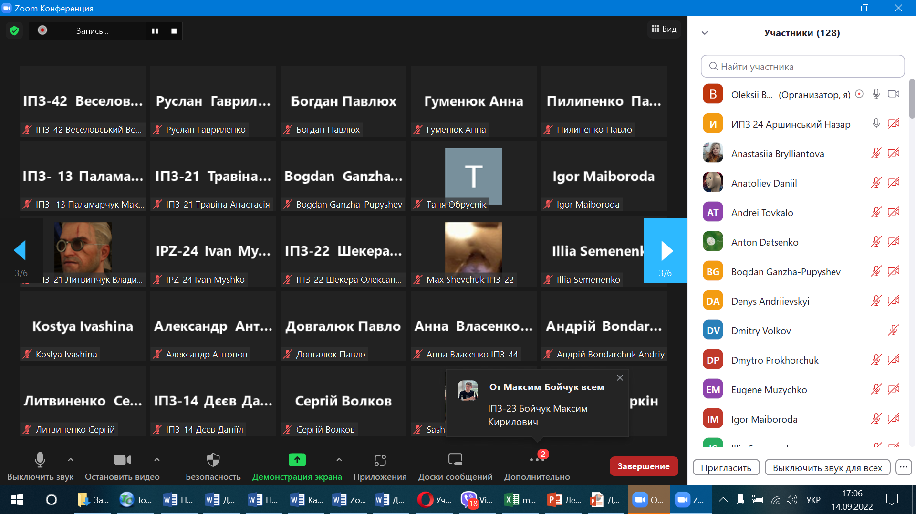

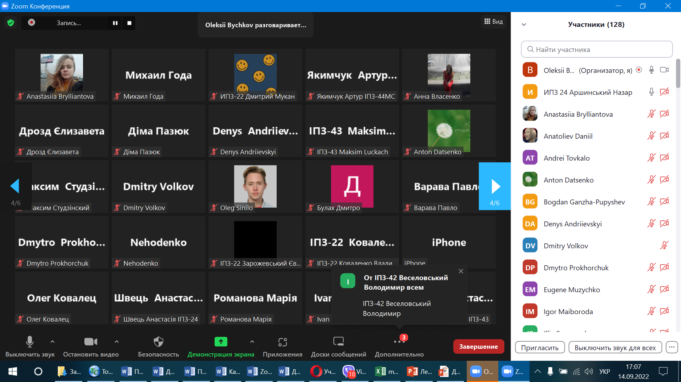

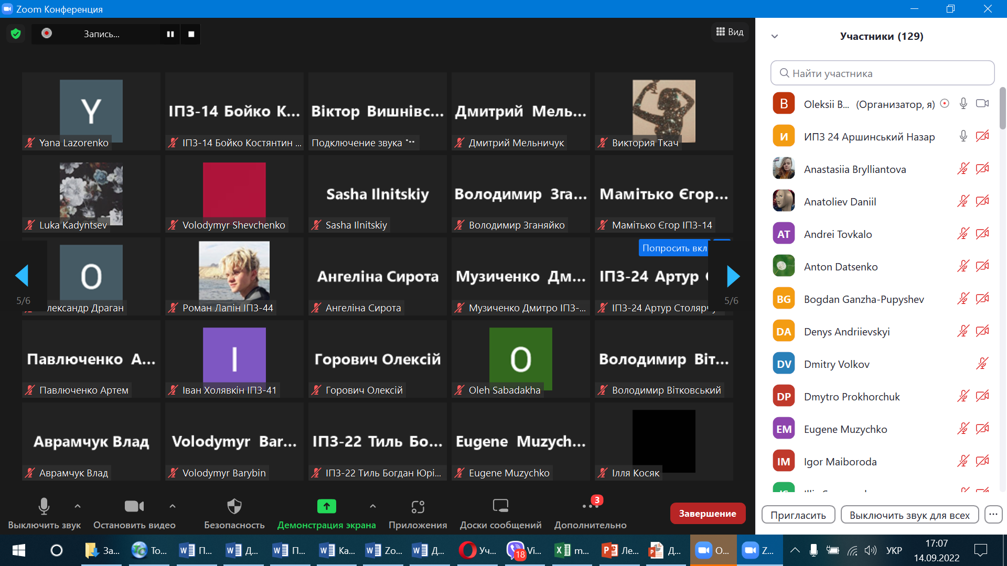

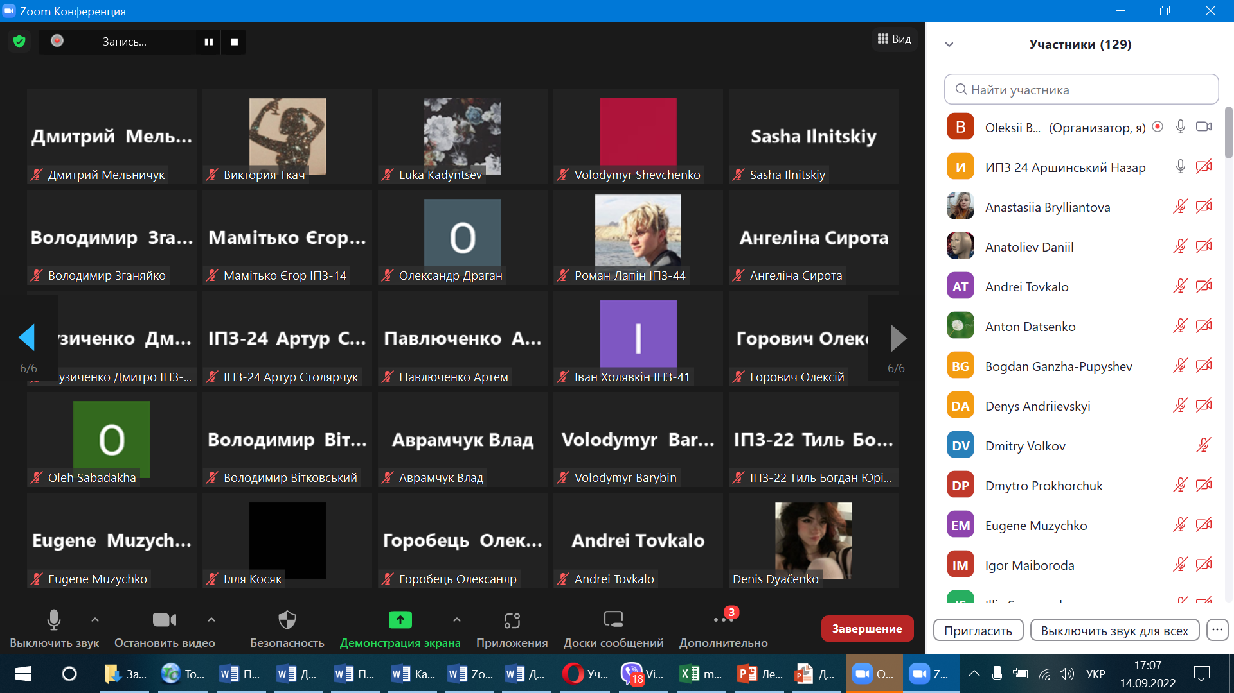

Finally, the event was concluded with productive discussions and networking.

Follow-up

As an integral part of multiplier event we’ve conducted the evaluation survey of the participants on quality of event’s organization and presented materials. The evaluation survey was performed by Google form. The link to online survey and screenshots of it are placed in the attachments. Evaluation form contained 8 questions to evaluate the event on a scale from 1 (worst rating) to 5 (best rating) and 1 open question about the comments and recommendations to the next events:

- Logistic preparation and organization of the event – on a scale from 1 (worst rating) to 5 (best rating)
- Format of the event's agenda – on a scale from 1 (worst rating) to 5 (best rating)
- Arrangements of the event (venue, equipment, etc) – on a scale from 1 (worst rating) to 5 (best rating)
- Duration and timetable of the event – on a scale from 1 (worst rating) to 5 (best rating)
- Communication between the organizers of the multiplier event and the participants – on a scale from 1 (worst rating) to 5 (best rating)
- Quality of presentations and other materials provided during the multiplier event – on a scale from 1 (worst rating) to 5 (best rating)
- Clearness of the presentation of the coordinator regarding project goals, implementation – on a scale from 1 (worst rating) to 5 (best rating)
- Opportunities to express your opinion and influence decisions – on a scale from 1 (worst rating) to 5 (best rating)
- Comments and recommendations for the next multiplier event – open question

We have obtained 56 responds to the event evaluation survey.

Results of the participants’ survey on logistic preparation and organization of the event:

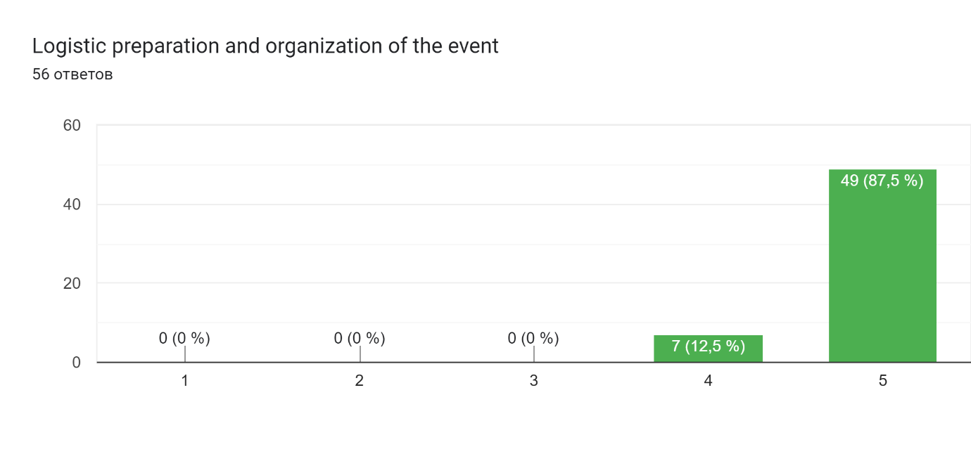

Results of the participants’ survey on format of the event’s agenda:
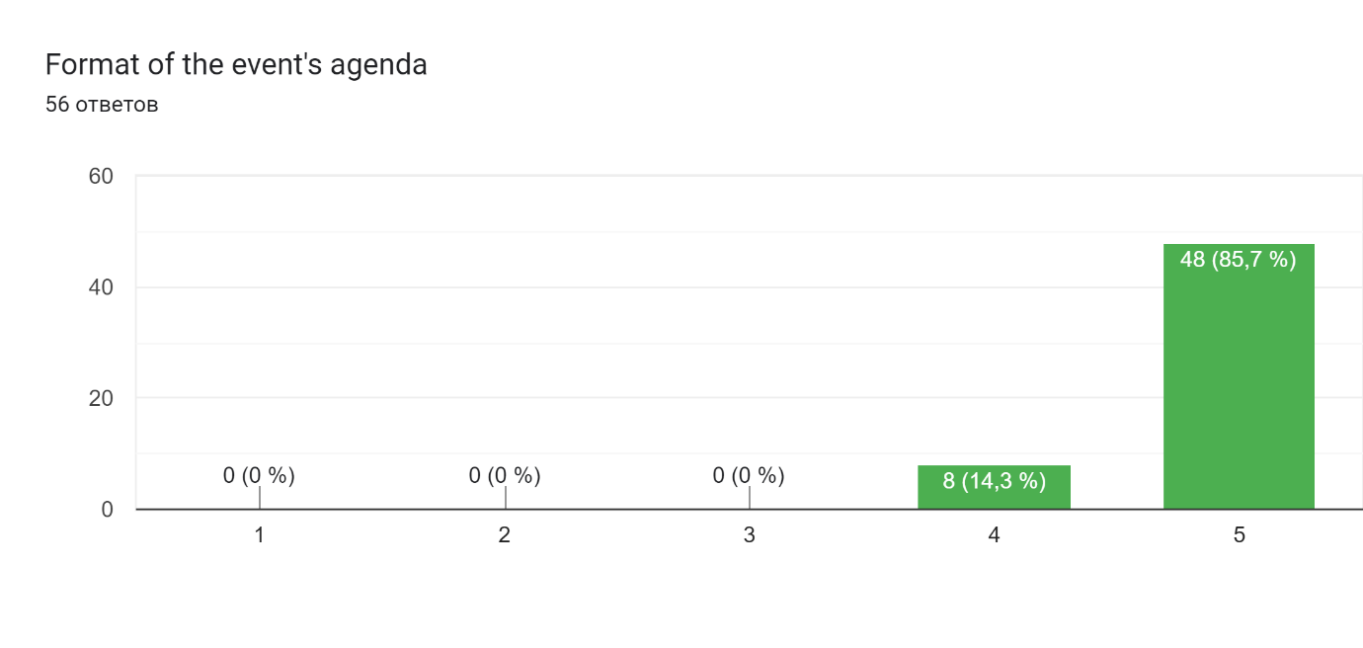
Results of the participants’ survey on arrangements of the event (venue, equipment, etc):
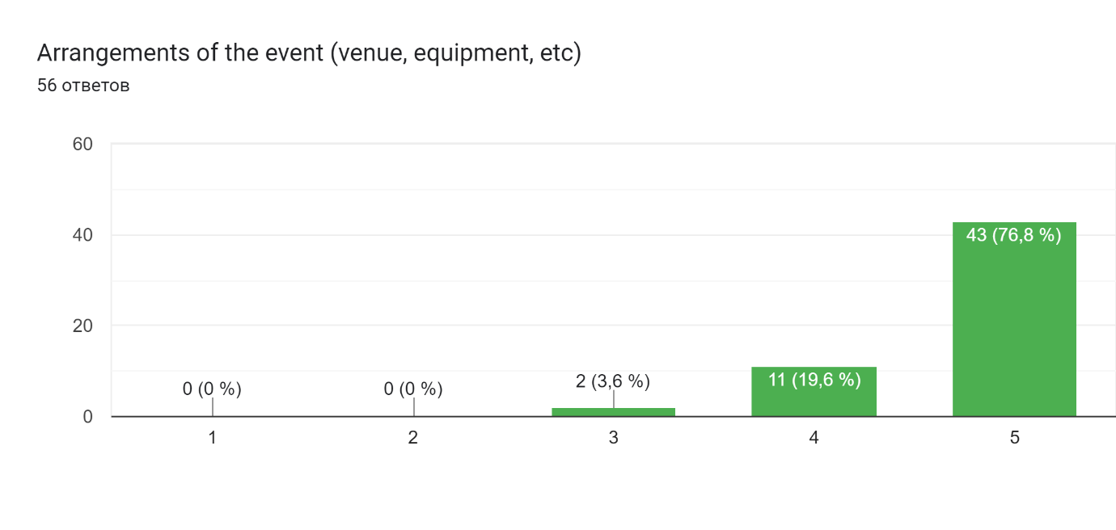
Results of the participants’ survey on duration and timetable of the event:
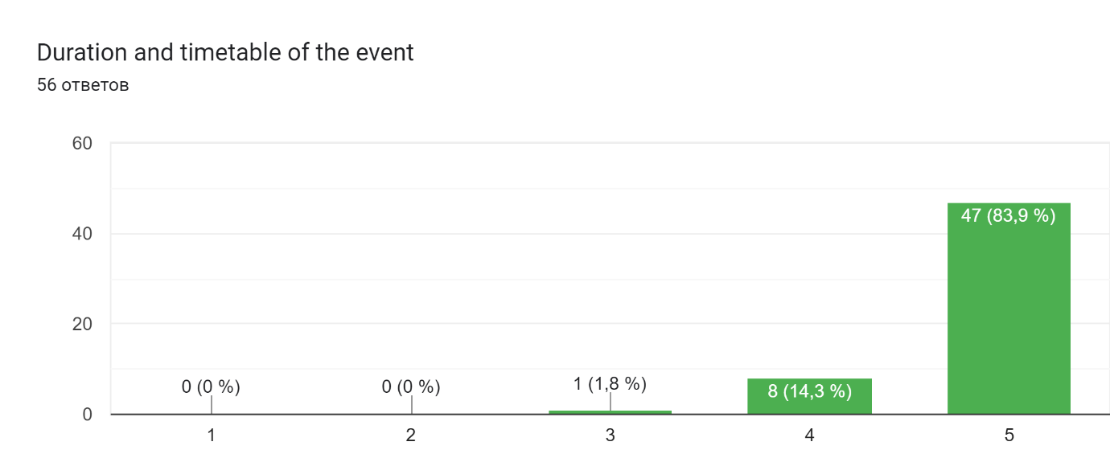

Results of the participants’ survey on communication between the organizers of the multiplier event and the participants:
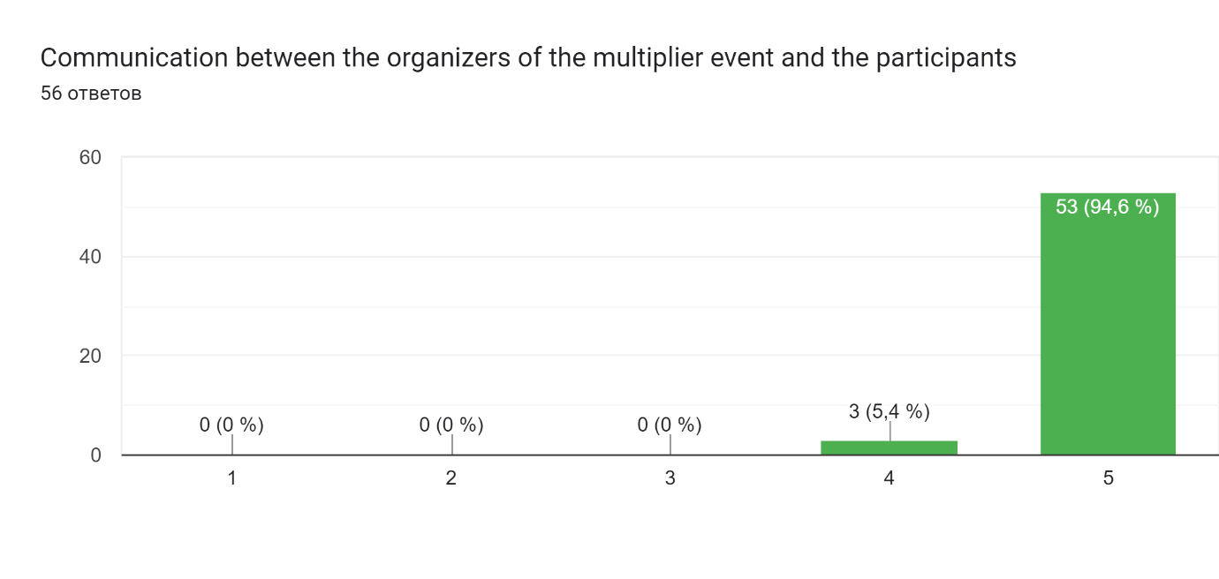
Results of the participants’ survey on quality of presentations and other materials provided during the multiplier event:
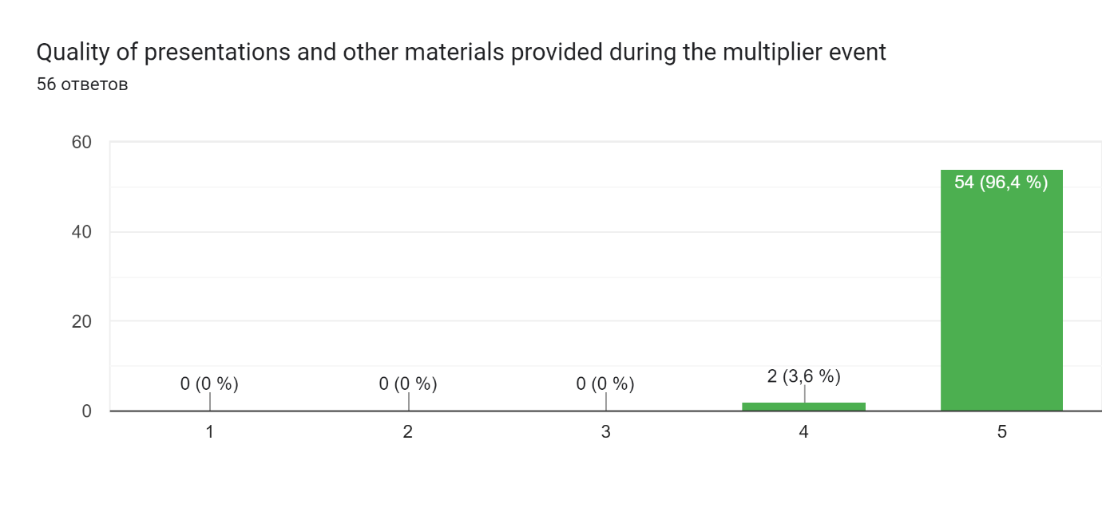
Results of the participants’ survey on clearness of the presentation of the coordinator regarding project goals, implementation:

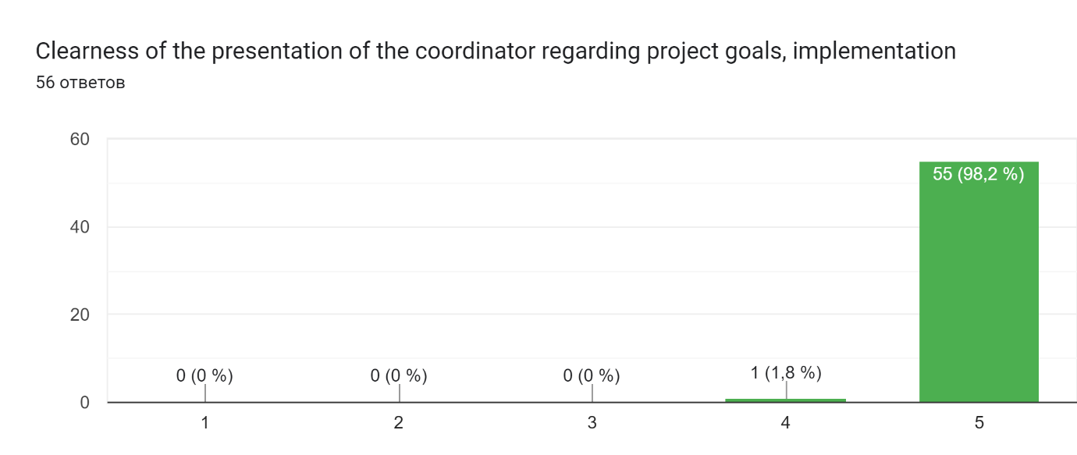
Results of the participants’ survey on opportunities to express your opinion and influence decisions:
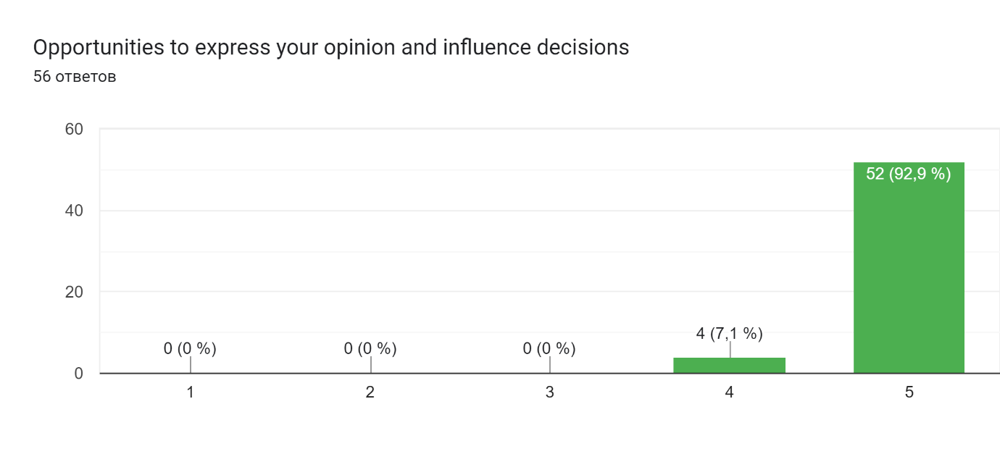

Attachments

A. Evaluation survey
Link to the evaluation survey: https://docs.google.com/forms/d/e/1FAIpQLSeo7T44lhQRml1pc76K95Yg21lyohg5NHEyr1l74D_bMx0PtA/viewform?usp=sf_link

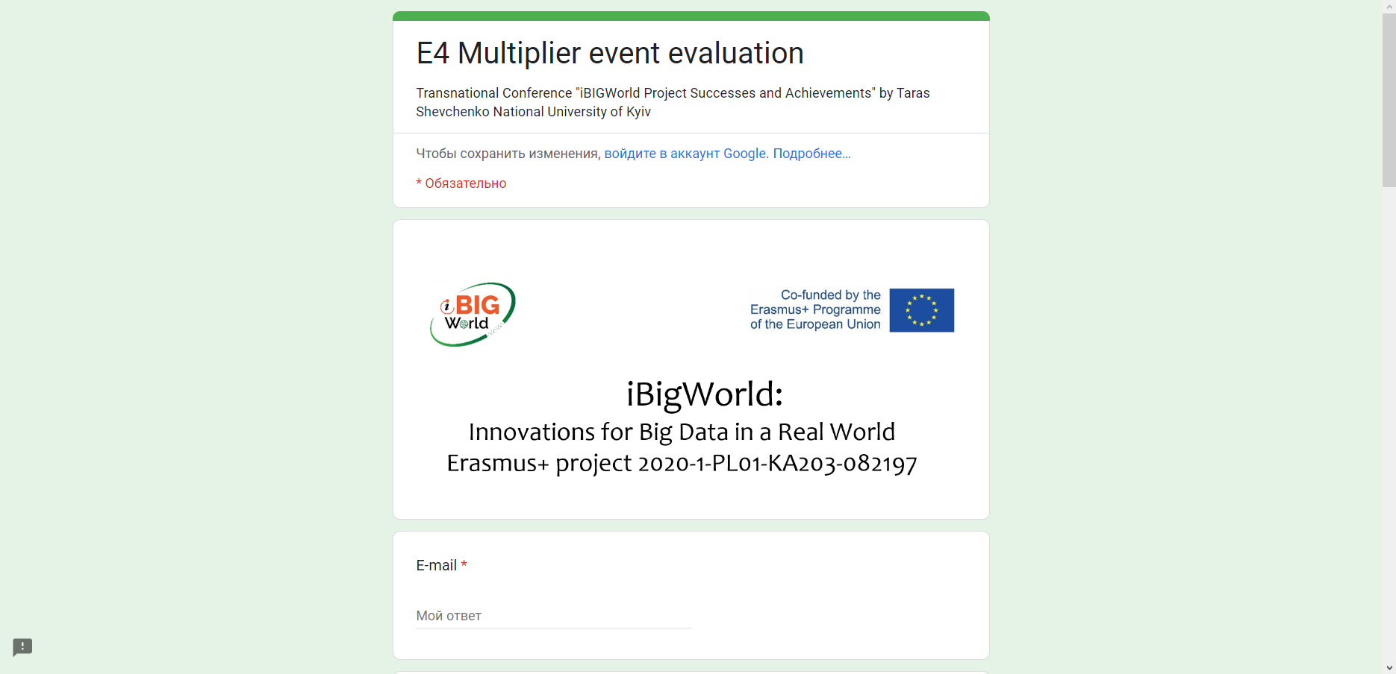
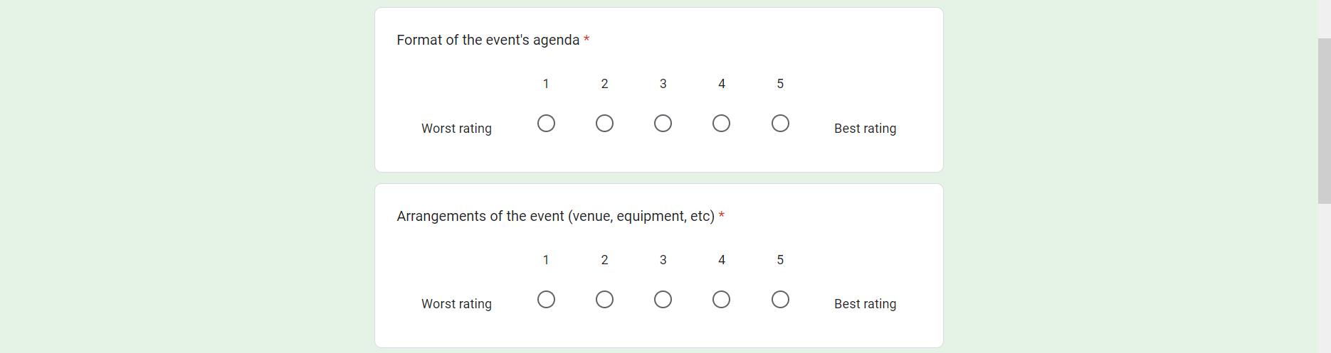
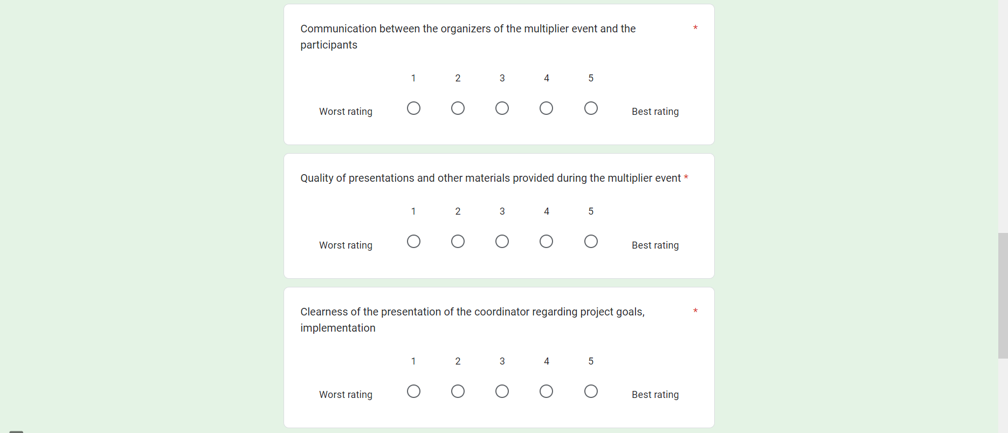
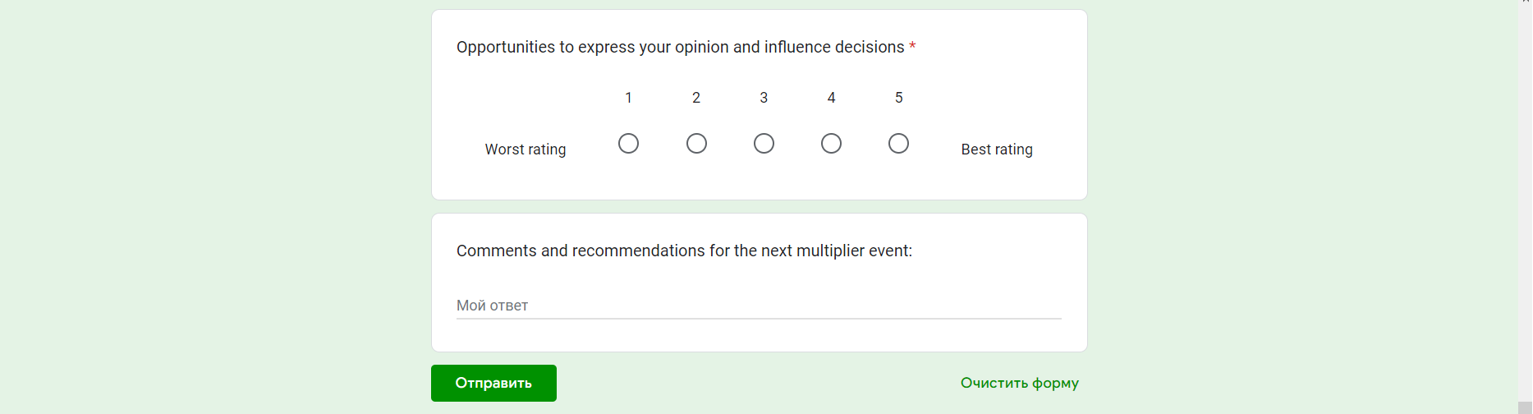

B. Presentations of reports

Link to the presentations: https://drive.google.com/drive/folders/1klMLlqldsL_WKYztML5Wd_RCM_4WVERx

C. Photo materials

Link to photo materials: https://drive.google.com/drive/folders/1KyjSxkTTj7-bIq0HiZ7N9kswljQx9Pm5

D. Participation list

